Card-inal Sin

By TBDragons Studios

# Members

* 1. Devon Grant
     + Lead Game Designer
     + Project Lead
     + Assistant Programmer
  2. Long Hoang
     + Lead Programmer
     + Assistant Audio Designer
     + Assistant Game Designer
  3. Matt Izzo
     + Lead AI Game Programmer
     + Lead Quality Assurance Engineer
  4. Sara Earl
     + Lead Art Designer
     + Lead Audio Designer
     + Lead UI/UX Designer

# Genre

* 1. Competitive card game: A type of card game that focuses on strategic deck building

# Plot

* 1. In the not so far off future humans crack the code to time travel, a rogue AI hacked the system and uses it to summon warriors throughout history in an attempt to take over the world, only you (the player) can stop it! Using your own time machine you recruit history's greatest warriors. Romans vs Samurai, Vikings vs Knights, Gods vs Man, Steel vs Flesh. Will you fight in the Battle of the ages? The fate of the human race lies in your hands, times ticking!

# Location

* 1. Battlefield

# Map (play area)

* 1. (Insert image)

# Legend

* 1. (Insert legend)

# Game design research

* 1. Board Game Design Day: Balancing Mechanics for Your Card Game's Unique Power Curve
     + [Board Game Design Day: Balancing Mechanics for Your Card Game's Unique Power Curve](https://www.youtube.com/watch?v=ul1MSQ8aW00)
  2. Designing Race for the Galaxy: Making a Strategic Card Game
     + [Designing Race for the Galaxy: Making a Strategic Card Game](https://www.youtube.com/watch?v=JcyyeAww2wc)
  3. What Can Video Games Learn from Collectible Card Games?
     + [What Can Video Games Learn from Collectible Card Games?](https://www.youtube.com/watch?v=cJtXYuSOe8g)

# Programming research:

* 1. [CCG Toolkit documentations](https://ccgtoolkit.wordpress.com/documentation/)

# AI research

* 1. [Unreal Behavior Tree](https://docs.unrealengine.com/4.27/en-US/InteractiveExperiences/ArtificialIntelligence/BehaviorTrees/BehaviorTreesOverview/)
  2. I plan on writing a basic decision tree and then playing the game while strictly following the tree as a way of honing the AI’s decision making.

# Audio design research: TBA

# UI research

* 1. Figure out specifications for art and capabilities of our framework

# Q/A research

* 1. The research I will conduct for Q/A is just a lot of playtests. Also researching fixes for any programming bugs that surface

# Research references

* 1. Devon
     + Game Developers Conference YouTube channel
       - <https://www.youtube.com/c/Gdconf>
  2. Matt
     + [PDF documentation for CCG Toolkit](https://ccgtoolkit.files.wordpress.com/2016/06/ccgtoolkit_documentation_v1-2.pdf) (specifically the AI section)

# Target audience

* 1. The target audience will be anyone looking to get into simple card games.

# Player motivation

* 1. The player will be motivated by the challenge of playing through the harder levels as well as the strategy of playing each match and how to build a deck specific to each level.

# Potential future Ideas

* 1. Having small snippets of dialogue from cards triggered by certain conditions
  2. A more fleshed out combat system with more thought out synergies and counters
  3. Monk faction
  4. God summoning
  5. Animations

# Game design goals

* 1. Balancing:
     + Balancing a card game is very important for this kind of game. Over the course of the semester the game should get progressively more balanced.
  2. “Triple battle”
     + Cards can’t attack cards that are opposite to them.
       - Card in the bottom left can’t attack card in the top right

# Programming goals

* 1. Gameplay menu:
     + Cards interaction: dragging cards into the available card spaces, enlarge cards on hover, …
     + Cards implementation: card attack animations, card abilities, damage calculations, status effect calculations, card combinations into higher tier
     + Pause screen: resume, back to main menu, audio options, exit to desktop
  2. Main menu:
     + Buttons for exit, options, deck building menu, game map
  3. Game map:
     + Access to deck building menu
     + Access to different stages and levels
     + Information about the current stage (name, factions, etc.)
     + Information about a level (difficulty level, enemy cards)
  4. Deckbuilding menu:
     + List of all cards and the quantity if the card is unlocked
       - Locked cards are grayscale
       - Unlocked cards have colors as well as the number of their quantity
     + Save and load decks for edit.
     + Edit selected deck.
     + Add a max capacity of card stats
  5. Level preparation menu:
     + Options for saved decks.
     + Enemy info: card list, etc.

# AI goals

* 1. The first step for making the AI will be to get it to make the smartest possible move for every situation. From there playtesting will help figure out if it needs to be dumbed down and by how much.

# Audio design goals

* 1. Enough sound effects to cover menu navigation, playing cards, card defeats, general defeat/victory

# UI/UX goals

* 1. Art present for all cards, and background
  2. Possible minimal animation for cards upon entering/attacking

# Q/A goals

* 1. The Q/A will use multiple playtests to get player feedback on the following features:
     + Balance and gameplay loop - Testing can use tabletop simulator to start before the digital game is in a playable state
     + AI
     + Visuals
     + Audio
     + Bugs

# Expected quality level

* 1. It is expected that we will get 2 or 3 well made levels. If we have time we will add more, but we will not compromise the quality of any level in order to add more.

# Player controls

* 1. Mouse and keyboard control:
     + Use cursor to drag cards into card spaces.
     + Hover cursor over cards for more information and enlarge a card.
     + Cycle through cards on hand using arrow keys and WASD keys.

# Game ruleset

* 1. Set Up
     + Both players draw three cards from their deck and place them face up on the field
     + Both players then draw three additional cards to keep in their hand
  2. Who goes first
     + The player with the lowest summed card rank goes first
  3. Combat
     + On the player's turn they may use one of their cards on the field to attack one of their opponents cards, damage of the attacking card is applied to the target card, and visa versa.
  4. Card death
     + If a card dies on the field, use one of the three cards in your hand to bring the total cards on your field back to three, if you have no cards left in your hand disregard this step
  5. Drawing
     + Players may draw a card from their deck if the amount of cards in their hand fall below three, if you can no cards left in your deck disregard this step
  6. Win Condition
     + Winner is determined when a player runs out of cards

# Combat mechanics

* 1. WIP
     + Royal Inspiration (Faction only):
       - Boost when with King (Dmg +3)/Queen (Hp +3)
     + Divine Inspiration (Faction only):
       - Boost when with Deity (Dmg +6, Hp +6)
     + Base Synergy:
       - All cards of same faction+1 dmg/hp
     + Call upon the gods
       - If Jack, Queen, and King are in play of the same suit you can summon that suits Deity card

# Card stats

* 1. 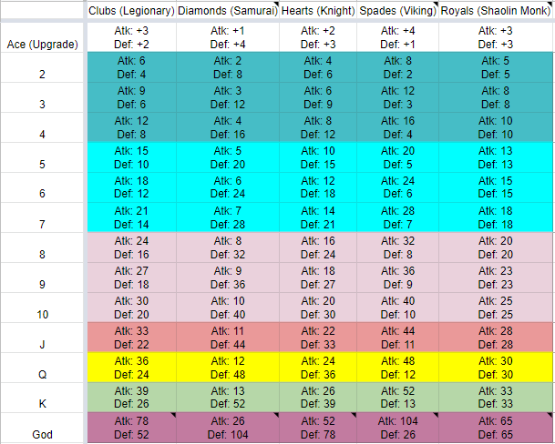

# Balancing

* 1. Our balancing philosophy is that with every card specializing in a different field, it opened the opportunity for their weaknesses to be exploited. This allows the player to fight the enemy and counter pick their opponent’s cards using their intuition and creativity

# Potential player abilities

* 1. Playing cards:
     + The player is supposed to have 3 cards in play every turn, so if one of their cards dies they will play a new card to replace it
  2. Attacking:
     + The player can use one of their cards to attack an enemy card
  3. Upgrading cards
     + Players can play an “Ace” card to upgrade one of their other cards. We plan on expanding this feature to include card merging but we don’t have the specifics worked out yet.
  4. Deck building:
     + Starting on the second level, the player will have the ability to choose which cards they want in their deck. Their deck will be premade for the first level.

# Game design direction

* 1. Make the game fun, by allowing the player more agency over their decisions as they progress through the game by allowing them to freely manipulate their deck, through clever strategies, trade offs, and playstyles, while simultaneously making the game fair for both players

# Art direction

* 1. Pixel art with small animation for cards
  2. More standard digital art, perhaps with a ‘painting’ style for backdrops and the like
  3. Keep a light-hearted, moderately silly feel while trying to differentiate the factions well.

# UI direction:

* 1. Depicting historical and mythological figures/units in a light-hearted, cartoonish and colorful way.

# Sound direction

* 1. We’ll use royalty-free audio for sound effects

# Art moodboards

* 1. Take inspiration from gen 4 and 5 pokemon in having pixel art with small animations to play at key moments

# UI/UX moodboards: TBA

# Audio moodboards: TBA

# Concept art: TBA

# Concept UI: TBA

# Concept sounds: TBA

# Game design assets: TBA

# Programming assets

* 1. CCG Toolkit: card game framework for Unreal Engine. [CCG Toolkit in Blueprints - UE Marketplace](https://www.unrealengine.com/marketplace/en-US/product/ccg-toolkit)

# AI assets

* 1. Unreal Behavior Tree

# Art assets

* 1. Art for each of the card levels

# UI/UX assets

# Audio assets: TBA

# Q/A assets

* 1. Q/A can determine some balancing via Tabletop Simulator. Once the game gets to a playable state this will instead be conducted there in addition to all of the other elements being tested.

# Software/Tools (everyone put the tools you expect to use in this section)

* 1. Game engine
     + Unreal Engine 4
  2. Source control
     + Perforce
  3. IDE:
     + Visual Studio
  4. Miscellaneous
     + Early balancing playtesting will be conducted in Tabletop Simulator

# Game states

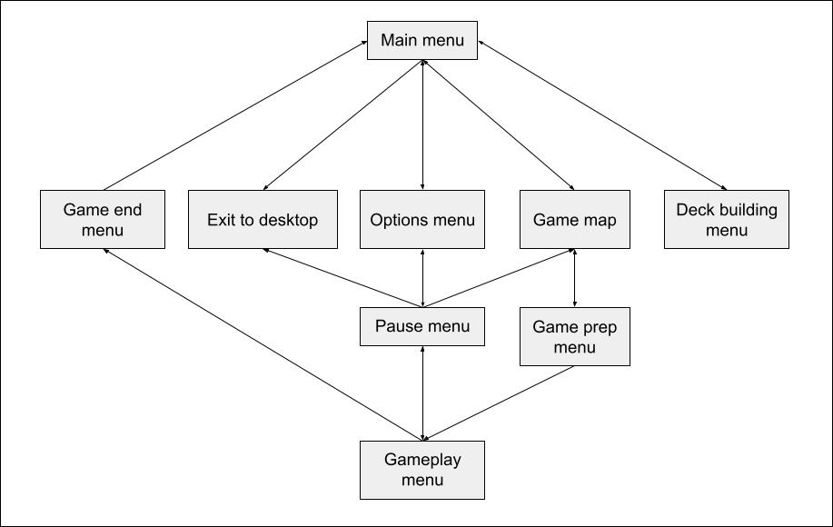

# Gameplay loop

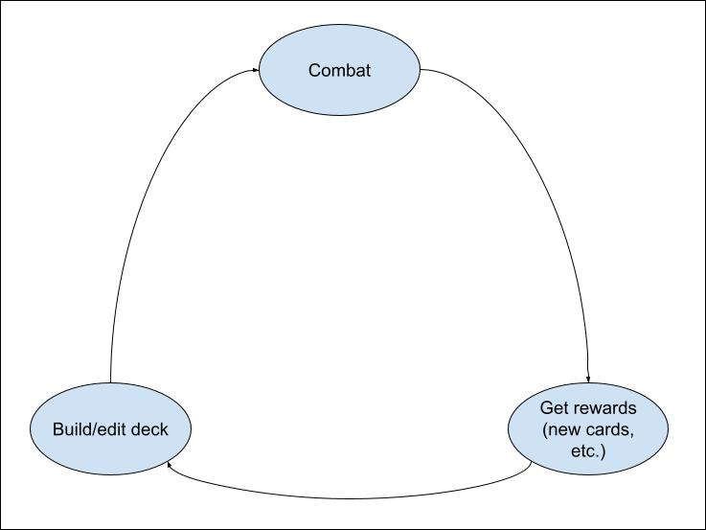

# MVP

* 1. 1 playable level
  2. Deck building
  3. 35 playable cards
  4. 5 powerups
  5. 2 or 3 card mechanics interactions

# Expected game design task

* 1. Experiment with cards giving synergy bonuses to each other
  2. Determine what the requirements are for a player made deck
  3. Experiment with merging cards together

# Expected programming task

* 1. Experiment and prioritize implementing gameplay menu and card functions for playtesting.
  2. Implement game map and deck building menu.
  3. Insert enemy AI into levels.
  4. Implement other game states and connect game states according to diagram

# Expected ai task

* 1. Figure out the optimal decision tree for each turn
  2. Determine if the AI is too good and if so how to make it easier.

# Expected art task

* 1. Determine specifications
  2. Create background art
  3. Create card art

# Expected UI/UX task:

* 1. Implement gameplay menu UI (pause button, card designs, etc.)
  2. Implement deck building UI (card list, deck list, etc.)
  3. Implement UI elements for other menu

# Expected audio task

* 1. Implement card interaction sfx.
  2. Implement menu interaction sfx.
  3. Implement card actions sfx (card attack, card defeat, etc.)

# Expected q/a task

* 1. Playtest at least once a week in tabletop simulator
  2. Once the unreal product is in a playable state playtests will be conducted there and be increased to at least twice a week.

# Expected time per task

* 1. Sara
     + About four hours available for working on art weekly on a consistent basis, at a wild guess. Much more may be possible, but not consistently so.
  2. Matt
     + I plan on playtesting for 1-2 hours a week and coding for 2-5 hours. I can spend more time if I suspect I won’t reach my goals in time for a milestone.
  3. Devon
     + 3 to 5 hours a week brainstorming, discussing, testing, and implementing new mechanics and ideas

# Weekly milestones

* 1. Week 1
     + Assemble team
  2. Week 2
     + Design doc
  3. Week 3
     + Setup all tools
     + Discuss work flows
     + Begin prototyping
     + Start card art (Viking)
     + Start development of very rough ai
  4. Week 4
     + Finish first prototype
     + Complete and implement first draft ai
     + Continue working on card art (roman)
  5. Week 5
     + Revise prototype if needed
     + Revise ai if needed
     + Continue working on card art (knights)
  6. Week 6
     + Playtest potential game mechanics
     + Start prototyping game ui/ux
     + Continue working on card art (monks)
  7. Week 7
     + Finalize game ui/ux prototype
     + Settings
     + Implement successful game mechanics
     + Begin to finalize Ai
     + Continue working on card art (samurai)
  8. Week 8
     + Work on any bugs that may arise
     + Implement final ai
  9. Week 9
     + Start to finalize mvp
  10. Week 10
      + Complete MVP
      + Start to work on level select
  11. Week 11
      + Begin development of addition ai types/behaviors
      + Polish any remaining game art/animations and add sound effects
      + Work on adding more cards types, if necessary
      + Start to work on text/voiceline interactions
      + Continue work on level select
  12. Week 12
      + Continue development of different ai behaviors
      + Add a general purpose menu with resolution sliders and different graphical options
      + Continue to work on text/voiceline interactions
      + Implement level select
  13. Week 13
      + Work on console controls available to the player
      + Implement player rating system
      + Fully implement text/voiceline interactions

# Schedule

* 1. This will be updated weekly with different weekly task for each member of the team

# Stretch goals

* 1. Matt
     + I think doing whatever work needed to make more levels is my stretch goal priority, but I would like to make difficulty levels for the AI.
  2. Long:
     + Game prep screen: player can choose a built deck before starting a level or create an entirely new one
     + Level rating at game end
     + Option menu:
       - Graphical options
       - Resolution
     + Console controls
  3. Devon
     + Would like add more warrior factions

# Potential future developments

* 1. Would like polish he game even more and add support for more platforms
  2. Publishing to itch.io